ADX FT8 Pocket: Another FT8 Oddesy March 2023

The notes describe how to install and use the ADX FT8 Pocket board shown below.

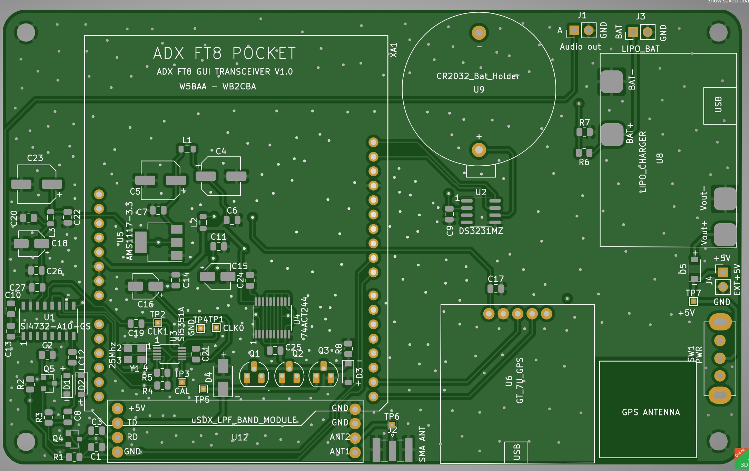

This board is fabricated to plug in directly to the Arduino Connectors on the backside for a STM32746 Disco board.

Please note that the design includes a DS3231MZ Real Time Clock with MicroElectroMechanical Systems (MEMS) resonator chip and a GPS module. The GPS module is required for setting the date and time handled by the Real Time Clock.

The board will work just fine without either of these items being installed, their time displays will just be blank during operation. FT8 decode synchronization is done manually and works just fine without the RTC or GPS modules installed.

In order for the application to run on the 746 Disco board you will need to install an SD card on the 746 Disco board with a Station Data file. The file should be named as StationData.txt and should contain a single line of test in the form YourCall:YourMadienheadLocator. Here is an example: W5BAA:EM00.

We did not include a phone plug on the ADX board since I like to use header pins instead. Also, I glued on a header pin socket on top of the Line In Phone plug on the 746 Disco Board. This makes for a much more compact connection scheme.

Further, you can monitor the Receive Audio by plugging in head phones into the Line In Phone plug. Actually, you can synchronize the FT8 decoding by simply listening for the lull in FT8 signals and then touching the Sync button.

Attributions

Several other amateurs helped in producing this project either by contributing hardware design and fabrication effort or by building out project boards and testing. Those helping include:

Barb, WB2CBA

Jim, W0CHL

Kees, K5BCQ

And, the underlying FT Decode algorithms were developed and shared by Karlis Goba, YL3JG

Board Fabrication

The board fabrication design was done by Barb. The Gerbers plus Bill of Materials are provided along with this document, STM32F IDE Source Code.

Plugging Everything Together and Turning It On

When the board is fully populated and plugged in you will see a display as shown below. The image below is taken without an antenna attached to the SMA connector on the board. The Si4732 has an effective Automatic Gain Control (AGC) which raises the Si4732 input gain to display the noise floor.

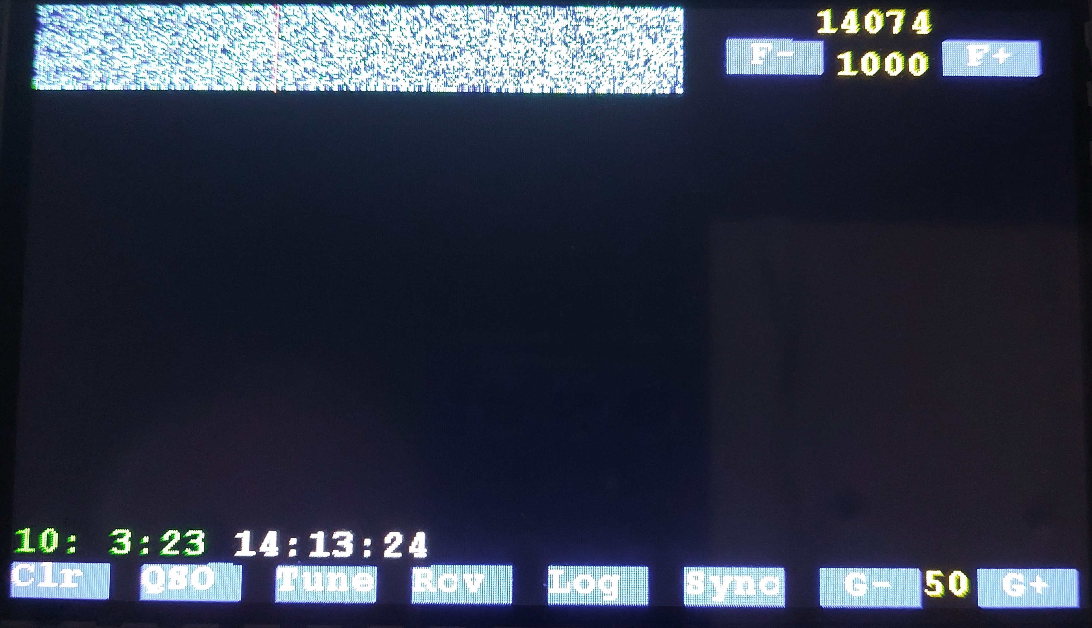

When an antenna is attached FT8 signals will show up nicely (if the band is working).

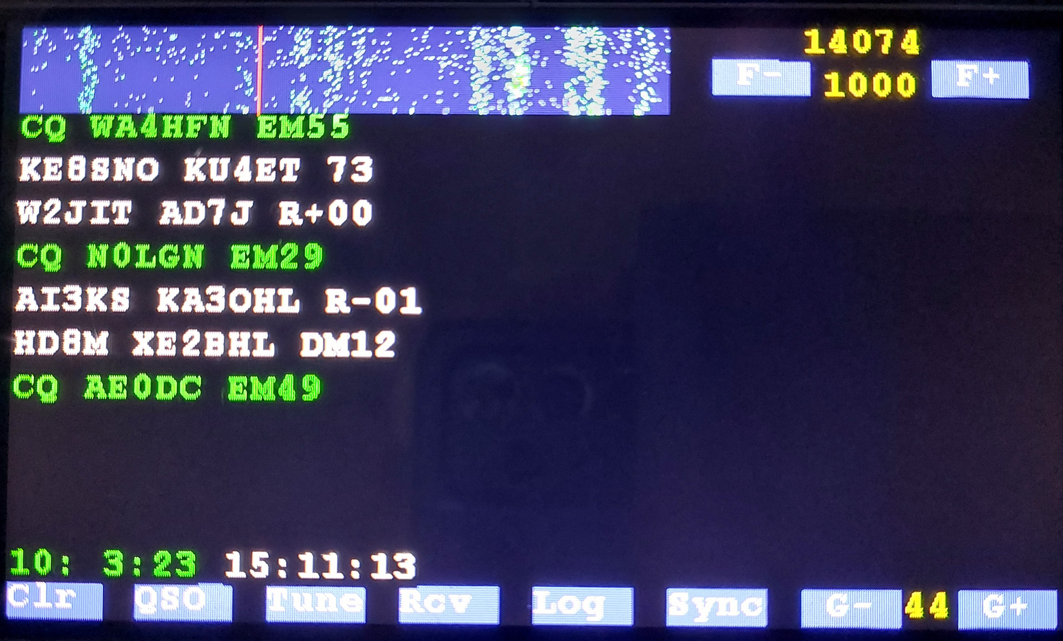

“Cheat Sheet Guide” to the display and touch areas and touch buttons.

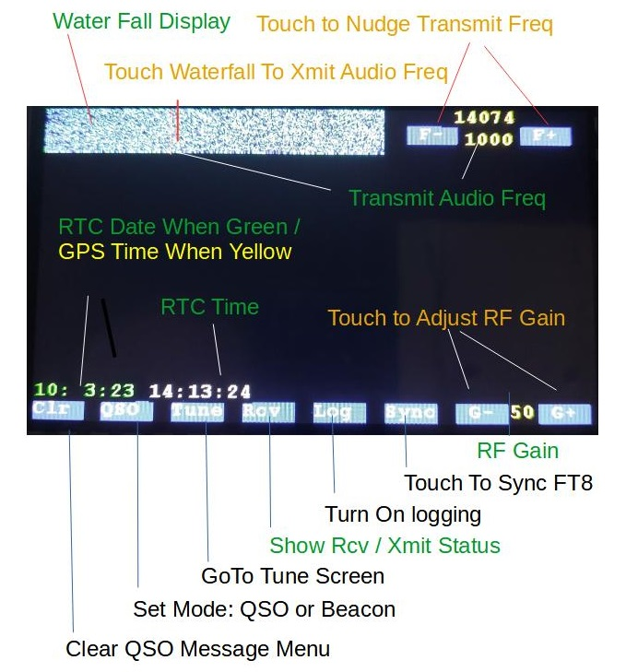

Synchronizing FT Decoder

When you have the antenna attached and you see FT8 signals the next step is to synchronize the FT8 decoder with the rest of the FT World as shown below:
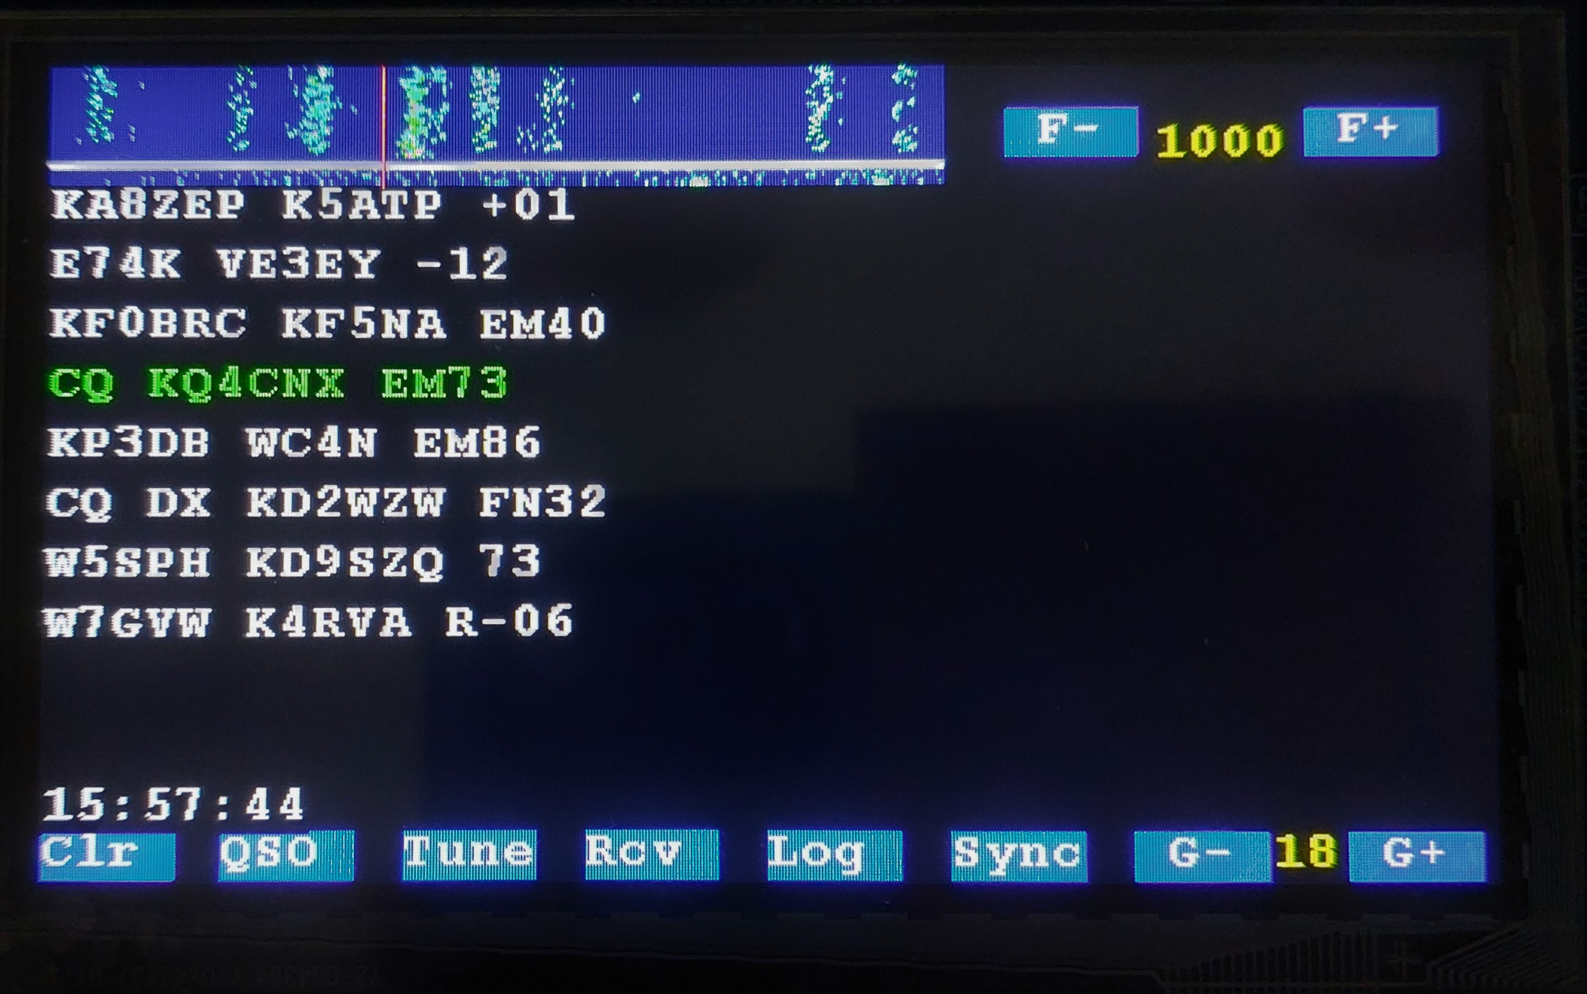
White Line Shows End of FT8 Slot
When you see the White Line at the bottom of the Water Fall, TOUCH the SYNC Button

This is a MANUAL method of synchronizing the FT8 decoder that was developed by Karlis Goba, the author of the underlying FT8 Code.

Much has been written, discussed, promulgated, and ex-posited about time synchronizing FT8 decoding.

And, several methods have been explored to use either a GPS Time signal or a Real Time Clock signal to automatically synchronize the FT8 decoder. None of these attempts worked as well as this MANUAL method.

When the FT8 Decoder is synchronized the FT8 decoded traffic is shown in the Left Hand Pane. Stations calling CQ are shown in Green Text for ease of identification.

QSO Operation Mode Notes

The FT8 application provides two modes of operation: QSO Mode and Beacon Mode.

In the QSO Mode you will be able to select a station to call and then manually select a composed message to send at the next FT8 Slot.

As you can see below the decoded FT8 traffic is shown in the left hand pane. Touching the station calling CQ, KW4UM generates a menu four messages for transmission which are shown in the Right Hand Pane.

Please note that you are NOT restricted from selecting ANY station in the Traffic List for QSO Message Generation. For this example the station calling CQ was selected.

More QSO Operation Mode Notes

In order to transmit a message, touch a message in the menu of FT8 messages to que the message for transmission on the next FT8 Slot.

In the figure below, the message shown in WHITE text as “KW4UM W5BAA -7 has been touched to be selected up for transmission and displayed in RED.

How about that folks

The message selected and displayed in RED will be transmitted in the next FT8 Slot.

More QSO Operation Mode Notes

So, with patience, persistence, and good propagation the station you are calling will respond and their response will be decoded as shown below. In this figure the FT8 messages you send and the called station response are shown in the UPPER RIGHT HAND PANE. Sent messages are shown in YELLOW while responses are shown in Orange / Red.

This is all of the functionality provided in the QSO Mode of operation. It is all manual and it is “What You See Is What You Get”.

If you chose to turn on the LOG feature the traffic shown in the above example will be stored on the Log File recorded on the Installed SD Card.

Be sure to turn off the LOG feature before turning the unit off so that you retain LOG contents.

Beacon Operation Mode Notes

The Beacon Mode Operation is configured to allow you to call CQ and to then respond automatically to FT8 Station calling you.

To enter the Beacon Mode, touch the QSO button and you will be presented with the display shown below.

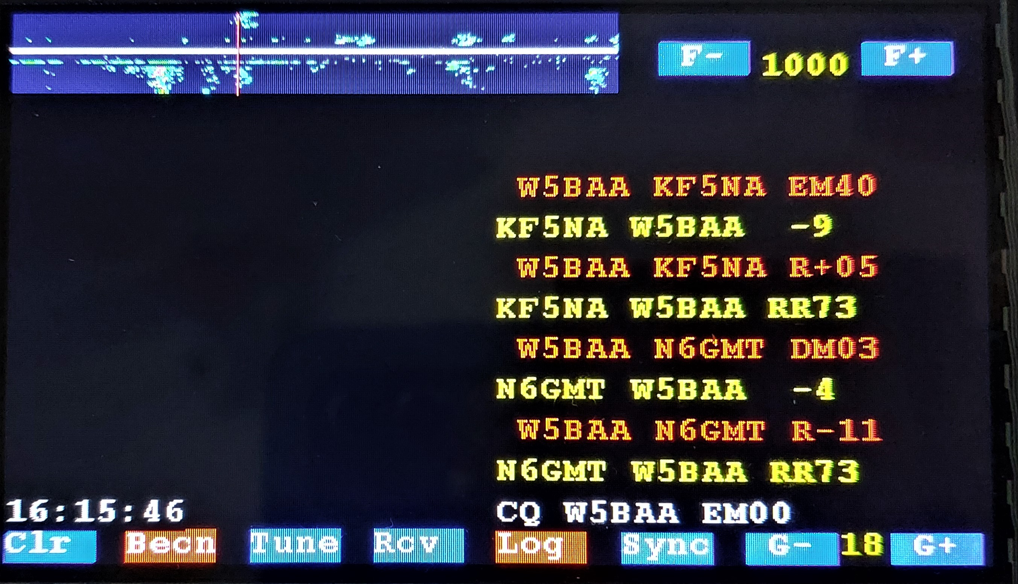

Again, the messages you send are shown in YELLOW and the responding FT8 Station Messages are shown in RED.

Since the Log button has been touched and is displayed in RED, a log of the FT8 Traffic has been recorded to the SD Card.

An example of the Log Entry recorded is shown below:

16:13:58 N6GMT W5BAA -4
16:14:28 W5BAA N6GMT R-11 1000 -4 0
16:14:28 N6GMT W5BAA RR73

Before you have the urge to be picky, the traffic was recorded with a Time Stamp which differs from the RTC time displayed because the photo was taken several minutes after the message was recorded.

That’s All Folks!

